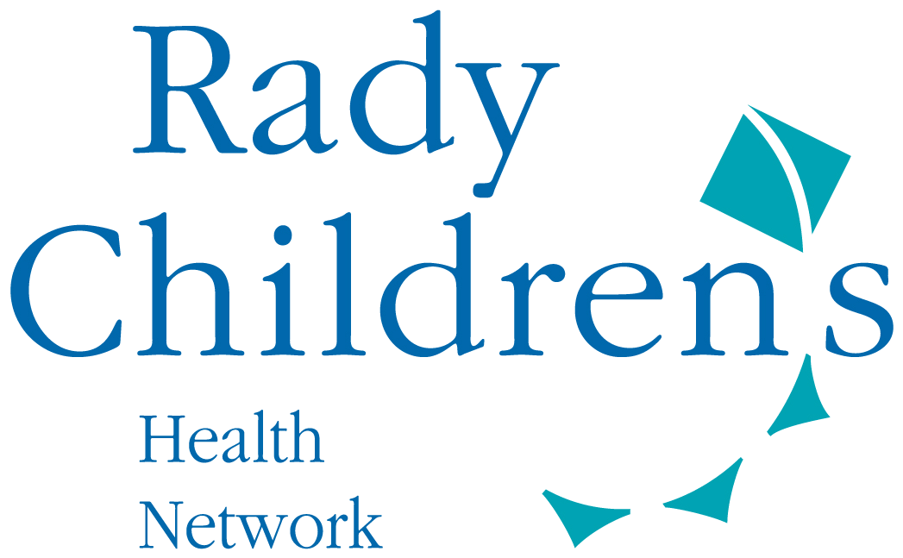
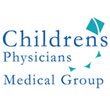

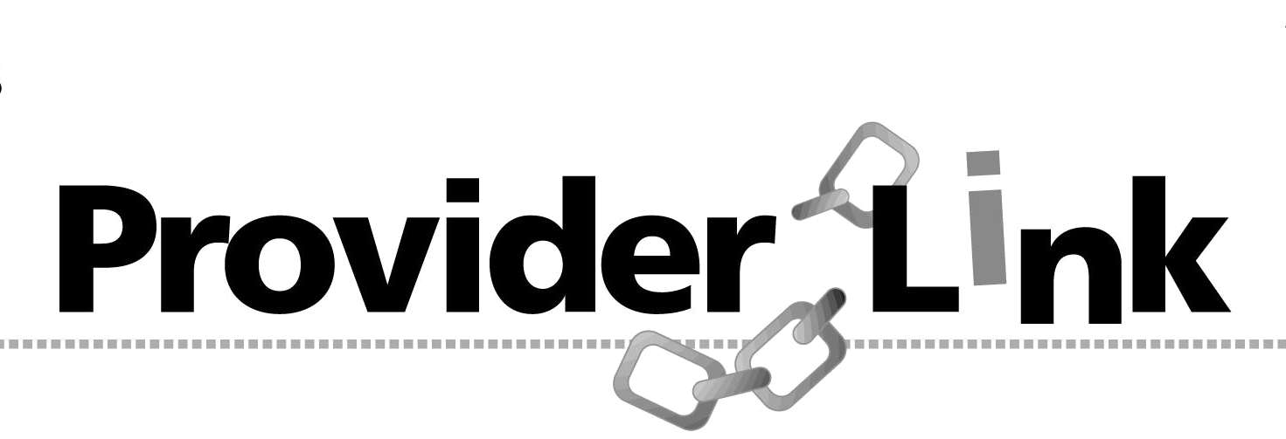
To: CPMG Providers

From: Children’s Physicians Medical Group, Inc. (CPMG)

Date: January 25, 2018

Re: CME Event: “32nd Annual Advances in the Practice of Pediatrics Conference”

_______________________________________________________________________

CPMG would like to invite you to the “32nd Annual Advances in the Practice of Pediatrics Conference” which will be held at the Hilton, San Diego on Friday March 23rd through Sunday, March 25th.

The conference is sponsored by Rady Children’s Hospital San Diego and the UCSD School of Medicine, and will provide CME credits.

For registration and more information, click: http:// www.pedsconference.com

Be sure you don’t miss the early bird deadline of February 13, 2018!

CPMG will reimburse $200.00 of the registration fees for any physician who wants to attend. Please provide your receipt of registration to the CPMG Provider Relations department as below, and we hope you enjoy the conference!

Should you have any questions concerning this notification, please contact the CPMG Provider Relations department as below:

Rhonda Kocher Taylar Neff
(858) 634-4951 (858) 634-4954
rkocher@rchsd.org tneff@rchsd.org

Visit us on our website: www.CPMGsandiego.com

