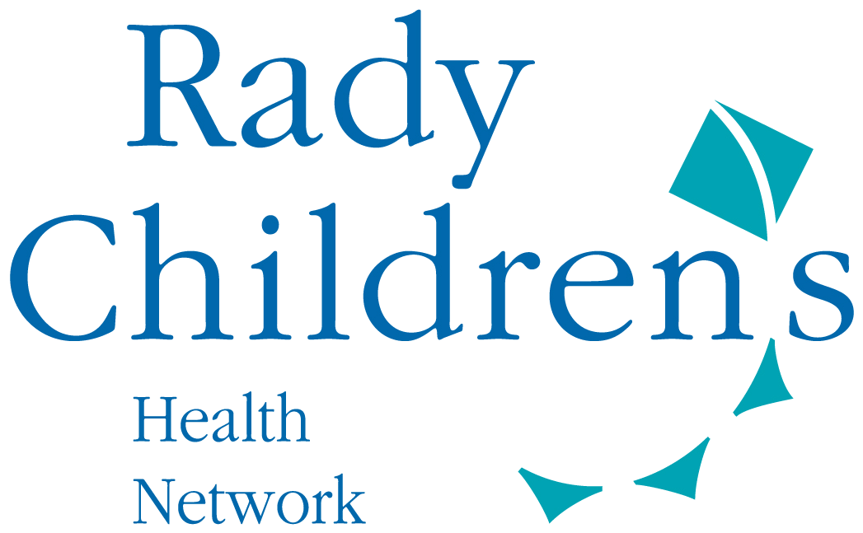
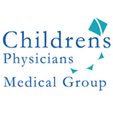

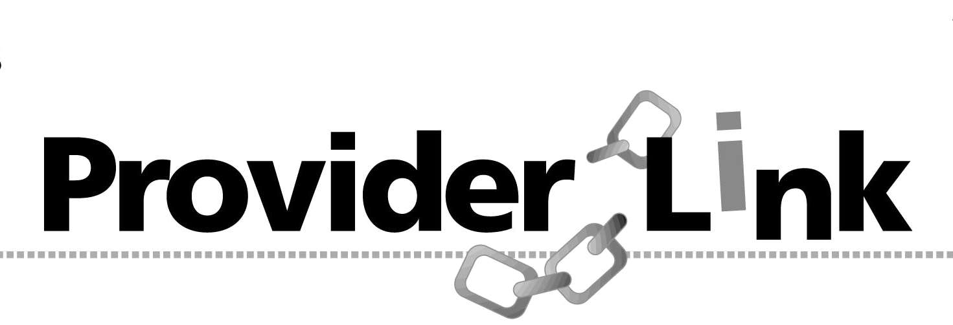
To: CPMG Providers

From: Children’s Physicians Medical Group, Inc. (CPMG)

Date: April 5th, 2018

Re: Annual Physician Meeting - SAVE THE DATE!
_______________________________________________________________________

We are excited to announce that Children’s Physicians Medical Group (CPMG) & Rady Children’s Hospital San Diego (RCHSD) will host the Annual Physician Meeting at the Hyatt Regency La Jolla at Aventine. Please note, the event will be held in November this year.
Please join us for an evening of networking with colleagues, delicious hors d’ouevres, wine, and dessert; be sure to hold the date and time on your calendars!

When: Thursday, November 1st, 2018

Time: 5:30 p.m. to 8:00 pm

Where: Hyatt Regency La Jolla at Aventine
3777 La Jolla Village Drive
San Diego, CA 92122

A formal invitation will be sent to your offices closer to the event date. We look forward to seeing you there!

Should you have any questions about this notice, please contact Rhonda Kocher at
(858) 634-4951 or rkocher@rchsd.org.

Visit us on our website: www.CPMGsandiego.com

